**FIN567 Financial Risk Management Homework 9**

Group name: SSVJ

Group members:

HOU Sunjie shou10

GADDA Veeraj gadda2

HONG Sungwook hong85

YOON Joonha joonhay2

Q1a:

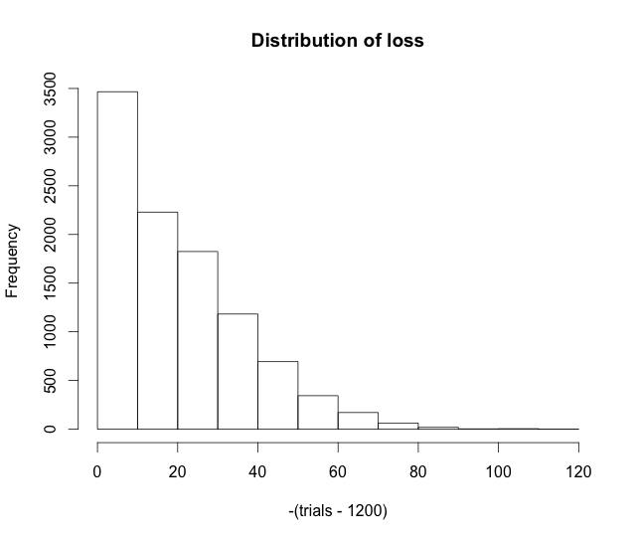

Q1b:

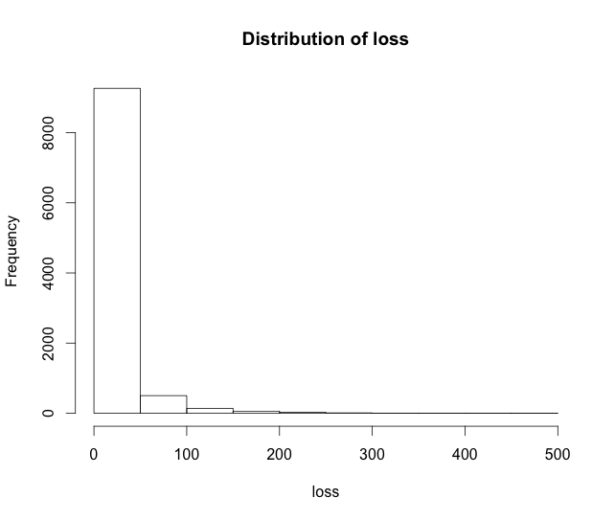

Q1c:



Q1d:



Q2a:



Q2b:



Q3a:

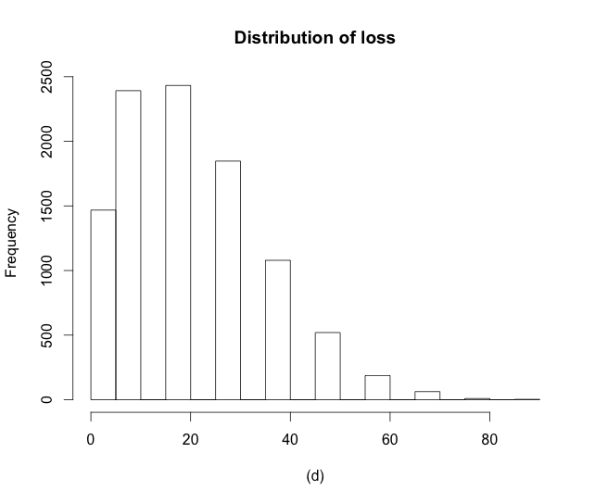

Q3b:



Q3c:



Q4 a:

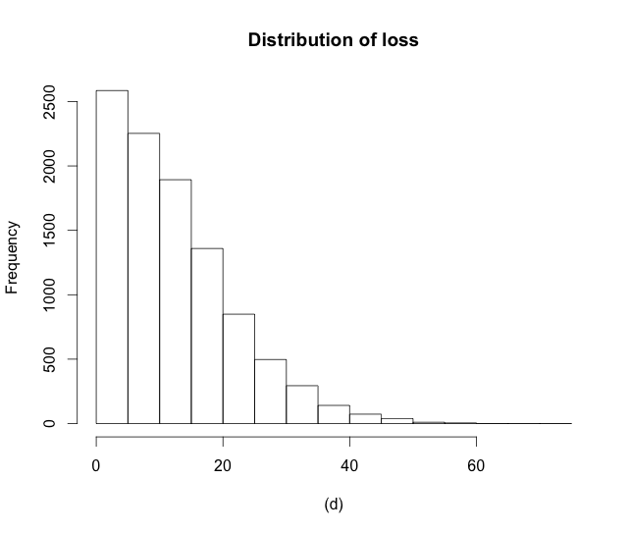

Q4 b:

